MODULE 2 ASSIGNMENT

1. Diabetes mellitus, cannot be classified as communicable disease because it is not caused by infectious agents and is not transmitted between people. There are two types of diabetes namely Type 1 and Type 2.

* Type 1 diabetes occurs when your immune system, the body’s system for fighting infection, attacks and destroys the insulin-producing beta cells of the pancreas. Scientists think type 1 diabetes is caused by genes and environmental factors, such as viruses, that might trigger the disease. Studies such as TrialNet External link are working to pinpoint causes of type 1 diabetes and possible ways to prevent or slow the disease.
* Type 2 diabetes—the most common form of diabetes—is caused by several factors, including lifestyle factors and genes.

Both types can occur when the immune system is affected. A person not eating healthily; consuming too much sugar, salts fats and meat products is likely to suffer for diseases like Blood pressure and diabetes. Infectious agents can contribute to weakening the immune system by causing some other communicable disease in the body. This can result to the body not being able to protect itself well enough hence diseases like diabetes will take effect and affect the person, but infectious agents on their own cannot directly cause the diabetes.

2. Pulmonary tuberculosis is a contagious, airborne infection that destroys body tissue. Pulmonary TB occurs when M. tuberculosis primarily attacks the lungs. However, it can spread from there to other organs. Transmission is through the air or respiratory by coughing or sneezing hence it is classified as airborne diseases using epidemiologic method.

This classification is important because it enables one to select prevention and control measures which are common to communicable diseases in the same class, such as Diphtheria, Pertussis, Meningitis (infection of the brain or spinal cord), and Pneumonia (infection of the lungs) so as to interrupt the mode of transmission.

3. Four or more bacterial vaccine-preventable diseases that have the same modes of transmission are:

* Diphtheria is an infection caused by the bacterium Corynebacterium diphtheriae. Diphtheria causes a thick covering in the back of the throat. It can lead to difficulty breathing, heart failure, paralysis, and even death. Transmission is through respiratory, by coughing or sneezing.
* Pertussis is also known as whooping cough, and is a highly contagious respiratory disease. It is caused by the bacterium Bordetella pertussis. Pertussis is known for uncontrollable, violent coughing which often makes it hard to breathe. After cough fits, someone with pertussis often needs to take deep breaths, which result in a “whooping” sound. Transmission is through respiratory, by coughing or sneezing.
* Meningitis is an inflammation of the membranes (meninges) surrounding your brain and spinal cord. The swelling from meningitis typically triggers symptoms such as headache, fever and a stiff neck. It is caused by bacterial. Transmission is through respiratory, by coughing or sneezing.
* Pneumonia which is an infection in one or both lungs usually caused by bacteria. The infection causes inflammation in the air sacs in your lungs, which are called alveoli. The alveoli fill with fluid or pus, making it difficult to breathe. Transmission is through respiratory, by coughing or sneezing.

4. Bacterial meningitis is an infection of the brain and spinal cord by the bacterium Neisseria meningitidis (also known as the meningococcus bacterium). The disease is caused by several groups of meningococcus bacteria, which are given distinguishing codes such as type A, B, C, Y and W135.

Methods for preventing bacterial meningitis include;

* Early identification and prompt treatment of cases in the health facility and in the community.
* Education of people in the community on the symptoms of meningitis, the mode of transmission and the treatment of the disease.
* Reporting any cases of meningitis to the District Health Office; and avoiding close contact with the sick persons. The health education messages should tell everyone about this.
* Vaccination against meningococcus bacteria of types A, C, Y and W135, as described in the Immunization Module.

5. Two characteristics that illustrate how the Anopheles larvae are different from other mosquito larvae are:

* Anopheles larvae have no siphon whilst Aedes and culex have siphon for breathing which it also uses to hang down from the water surface.
* Anopheles larvae rests parallel to and immediately below the water surface while culex and Aedes rest at an angle below the water surface.

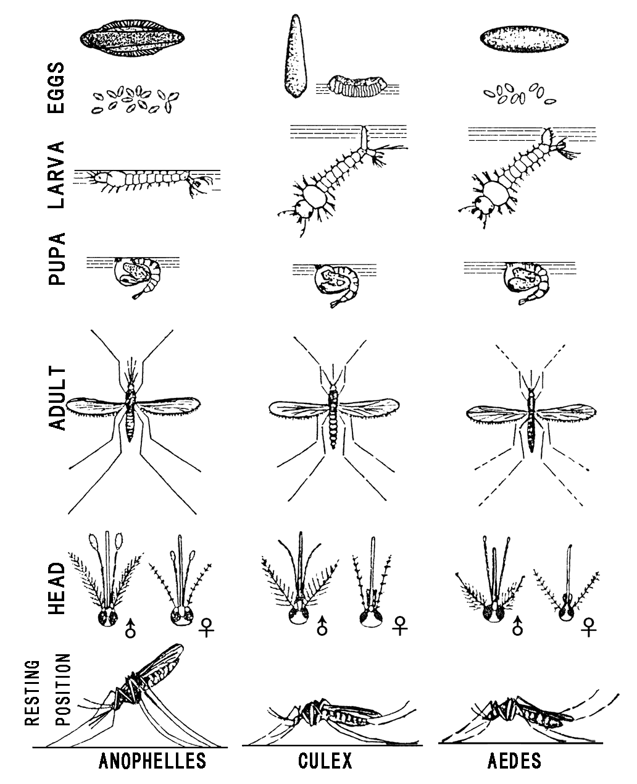

Diagram showing resting position of Anopheles, Culex and Aedes mosquito

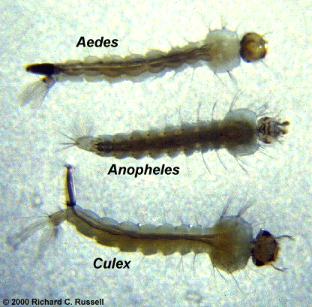

Diagram highlighting siphon of the Aedes and Culex mosquito. The anopheles does not have any.

**REFERENCE**

<https://www.niddk.nih.gov/health-information/diabetes/overview/symptoms-causes>

<https://www.researchgate.net/post/How_to_identify_Culex_Anopheles_and_Aedes_mosquitoes_and_their_larvae>

<https://www.cdc.gov/meningitis/bacterial.html>

<https://www.healthline.com/health/pulmonary-tuberculosis>

WASH Module 2 Notes